# Assumptions

1. Assume that node.js is installed successfully on machine
2. Cypress.io is installed successfully

# Steps to run project

1. Download the project folder
2. Either copy cypress file from my project and paste content in your file
3. Set all the variables as per valid data so that these values can be used in the script from cypress.json file

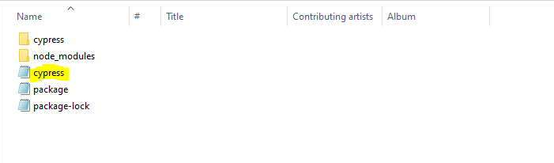

# Open the folder where you have copied the project

1. Navigate to from Project folder Cypress Test->cypress->integration->2-advanced-examples
2. In this folder, paste script file named “Computer_Database_Project.spec.js” file
3. Open the cmd in the folder Cypress Test location
4. Execute the command – npx cypress open and enter
5. Cypress UI is opened
6. Click on the “Computer_Database_Project.spec.js”
7. This will execute and generate result in chrome

# Note

If you have already installed Cypress.io then you can directly copy the file named - Computer_Databse_Project.spec and paste into your directory of **“..\cypress\integration\2-advanced-examples”** and while executing open cypress UI and click on this file, it will execute.